Contents
Introduction and Acknowledgments 4
Version Control 4
Acknowledgments 4
Research Data Request Workflow 5
Protected Health Information (PHI) 6
Limited Data Sets vs. De-identified Data Sets 7
What is a limited data set (LDS)? 7
What is a de-identified data set? 7
Why create a limited or de-identified data set? 7
How do researchers obtain a limited or de-identified data set? 7
Do I need to track “accounting of disclosures” for limited or de-identified data sets? 8
Do I need a data use agreement (DUA) for limited or de-identified data sets? 8
Data “Use” vs. “Disclosure” and Accounting of Disclosures (AoD) 9
What is the “use” of PHI data? 9
What is a “disclosure” of PHI data? 9
DH Affiliate Covered Entities and DH Workforce 9
What is “accounting of disclosures”? 10
Do I need to account for disclosure of limited data sets (LDS) or de-identified data sets? 10
How do I do the accounting of disclosures (AoD)? 10
Unauthorized Disclosure of PHI and Data Breaches 11
What is a data use agreement (DUA)? 12
When do I need to use a DUA? 12
Do I need a DUA if I am sharing (disclosing) a limited data set or de-identified data set? 12
Do I need a DUA if I am sharing aggregated results? 12
What is the Master Data Use and Transfer Agreement (MDUTA)? 12
How do I get a DUA written and signed? 12
Conducting Manual Chart Reviews 13
Who may conduct the manual chart review? 13
Do I need approval before conducting manual chart review for research? 13
When is manual chart review allowed? 13
How do I get approvals for manual chart review? 13
Waiver of HIPAA Authorization 14
What is a Waiver of HIPAA Authorization and why is it required? 14
Do I need a Waiver of Authorization for a limited data set or a fully de-identified data? 14
Do I need a Waiver of Authorization if the data is not being disclosed outside of DH? 14
Do I need a Waiver of Authorization for data about Decedents? 14
Do I need a Waiver of Authorization to use TriNetX? 14
How do I request a Waiver of HIPAA Authorization from DH IRB? 14
Patient Consent to Collection and Disclosure of PHI 15
Readily Reportable Data for Research 16
Data elements 16
Dates data became available in Epic by affiliate organization 19
Privacy Office Review Replaced by Research Informatics & Data Governance (RIDGe) as of 1/1/2024 20
What studies need RIDGe review? 20
How do we get a study to RIDGe for review? 20
Use of Clinically Sensitive or Business Confidential Data 21
Substance Use Disorder (SUD) treatment 21
Research use of HIV or genetics data 21
How research teams should plan for use of clinically sensitive data 21
Business confidential data 21
Disclosure of clinically sensitive or business confidential data outside DH or Dartmouth College 21
Social Security Numbers 21
IND/IDE data capture and storage in a 21 CFR 11 compliant system 22
Who must use a 21 CFR 11 compliant system? 22
What is EDC? 22
Why did DH implement EDC? 22
What are the key features of EDC? 22
What support will be available to the PI of a study that is required to use EDC? 22
Approved Places to Store Research Data 23
Data used within DH 23
What is DH REDCap and who can use it? 23
De-identified data shared to Dartmouth College 23
Identified or limited data set (LDS) shared to Dartmouth College 23
Data use agreement with Dartmouth College 23
What is Granite and who can use it? 23
Removing data from Granite 23
Storing data not at DH or at Dartmouth College 24
Table of Places to Store DH Data 25
How to Transfer Data in or out of DH 26
Requesting Data for Quality Improvement vs. Research 27
Are you considering publishing your QI or research project? 27
Projects that are clearly QI and will not be published 27
Projects that you can’t decide are clearly QI or research 27
How can I make it clear to the IRB that my project is likely QI 27
Special Considerations with Students 28
Update 4/2024 28
Geisel students enrolled in the MD program might be DH workforce. 28
Other Dartmouth students (not MD) and all non-Dartmouth students are not DH workforce 28
Reviews Preparatory to Research 29
Using Data from DH Patients Who Died (Decedents) 30
Do I need a Written Authorization or a Waiver of Authorization for data about Decedents? 30
What language is needed to request research use of Decedent data? 30
Version Control 31
Appendix 1: An instrument to differentiate between clinical research and quality improvement 33
Appendix 2: Research Data Request Workflows 35
1. Neither RIDGe nor DUA required (Data not disclosed outside DH) 35
2. Only DUA Required (Data disclosed outside DH) 35
3. Only RIDGe Required (Data not disclosed outside DH. Approval needed for special data or apps) 35
4. Both RIDGe and DUA required – less common (Data disclosed outside DH. Approval needed for special data or apps) 35
5. Manual Chart Review with Analytics Institute assistance – RIDGe review required 35
6. Manual Chart Review without Analytics Institute assistance – RIDGe review required 35

Introduction and Acknowledgments
In 2023, the DH Office of Research Operations Informatics team and many partners responded to feedback and significantly improved how researchers request data and how the requests are approved.
- We eliminated the requirement that all research data requests have an initial appraisal from the Analytics Institute honest data brokers.
- We removed the requirement that the Privacy Office review all research data requests.
- We created this Research Data Handbook and the new Research Data Request form to offer guidance on how to request data in a manner most likely to be approved.
- We formed the Research Informatics and Data Governance (RIDGe) group, with members of clinical informatics, research informatics, IRB, Analytics Institute, and Privacy Office. RIDGe meets weekly to review research projects, eliminating long delays.
- The SYNERGY Informatics Team hired two new analysts who are available for Research Data Concierge consultations.
- We developed a unified intake form for all research data and informatics questions, and consult requests, available to DH staff as a DHSM self-service ticket.
- We built the SYNERGY website as a one-stop place to find updated versions and other guidance, and we made the website outside the DH firewall so that it is accessible to Dartmouth College researchers, too.
The purpose of the handbook is to standardize and organize Dartmouth Health knowledge about the acquisition and use of data for research purposes.

Version Control – We recognize that the Handbook is evolving, and we will offer newer versions at least bi-annually. The latest version will always be posted to the Dartmouth SYNERGY website: Data Management and Security – Dartmouth SYNERGY (https://synergy.dartmouth.edu/data-management-and-security/)

Acknowledgments – The Handbook was the result of many people meeting weekly over several months to reach consensus on the outline and the content:
- ORO IRB: Shannon Sewards, Tonya LaClair, Michael Hill, Cristina Ferrazzano Yaussy
- ORO Informatics: Jen Snide, Robyn Mosher
- Clinical Informatics: John Mecchella, Todd Morrell
- Information Services Analytics Institute: Carole Felone
- Privacy Office: Rebecca Malila
Caren Saunders was invaluable as ORO Project Manager in keeping the team moving forward.
With gratitude for their dedication to DH research,
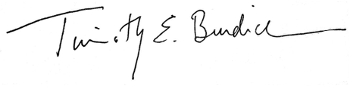
Tim Burdick MD MSc MBA
Associate Chief Research Officer for Informatics, Dartmouth Health
Associate Professor and Vice Chair of Research, Community and Family Medicine

Research Data Request Workflow

Please read this whole handbook carefully to avoid problems. The SYNERGY/ORO Informatics team is always available for consultation to help make your data acquisition as smooth as possible.
In most cases, your project will not require review from Research Informatics and Data Governance (RIDGe). In that case, the main decision point is whether or not you need a data use agreement (DUA).
- For DH-only projects (read handbook for details), you will not need a DUA.
  - Upload your Research Data Request Form and IRB protocol in eIRB where they will be in the pre-submission stage.
  - After your study is reviewed by IRB and you push it to OnCore, your study will eventually become Active in OnCore, indicating that it has passed all the requirements.
  - Once Active in OnCore, submit your DHMS self-service ticket to request research data.
  - The Analytics Institute (AI) honest data brokers will not work on tickets until the study is Active in Oncore. (If you have asked for a consultation from the SYNERGY Research Data Concierge team, the AI data brokers may do some preliminary work, but they will not release any data until the study is Active in OnCore.)
- For projects including Dartmouth College or other non-DH researchers, you will need a DUA. The Master Data Use and Transfer Agreement (MDUTA) might meet the DUA requirement, determined by CTO/SPA during their review.
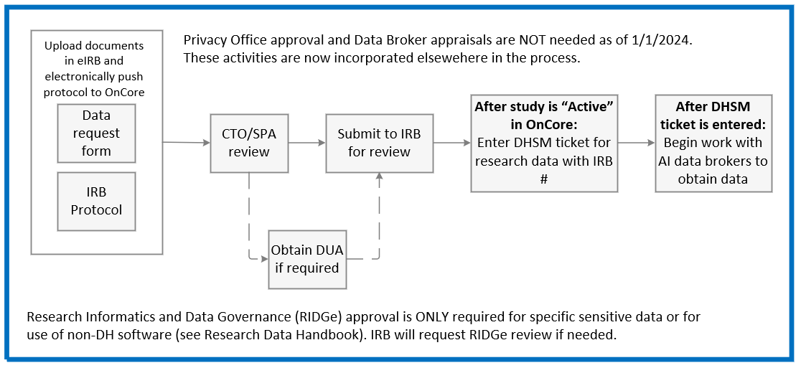
For detailed workflow diagrams, see Appendices.

Protected Health Information (PHI)

Protected Health Information (PHI) has a very specific definition. It is extremely important to understand PHI since mistakes can lead to unlawful violation of patient privacy and significant Federal fines. PHI is any information in the medical record or designated record set that can be used to identify an individual and that was created, used, or disclosed in the course of providing a healthcare service such as diagnosis or treatment.

An identified data set is any collection of data with any one or more of these 18 identifiers:
1. Names;
2. All geographical subdivisions smaller than a State, including street address, city, county, precinct, zip code, and their equivalent geocodes, except for the initial three digits of a zip code, if according to the current publicly available data from the Bureau of the Census: (1) The geographic unit formed by combining all zip codes with the same three initial digits contains more than 20,000 people; and (2) The initial three digits of a zip code for all such geographic units containing 20,000 or fewer people is changed to 000.
3. All elements of dates (except year) for dates directly related to an individual, including birth date, admission date, discharge date, date of death; and all ages over 89 and all elements of dates (including year) indicative of such age, except that such ages and elements may be aggregated into a single category of age 90 or older;
4. Phone numbers;
5. Fax numbers;
6. Electronic mail addresses;
7. Social Security numbers;
8. Medical record numbers;
9. Health plan beneficiary numbers;
10. Account numbers;
11. Certificate/license numbers;
12. Vehicle identifiers and serial numbers, including license plate numbers;
13. Device identifiers and serial numbers;
14. Web Universal Resource Locators (URLs);
15. Internet Protocol (IP) address numbers;
16. Biometric identifiers, including finger and voice prints;
17. Full face photographic images and any comparable images; and
18. Any other unique identifying number, characteristic, or code (note this does not mean the unique code assigned by the investigator to code the data)

If you are working with data that includes ANY PHI, be sure to follow guidelines relating to Data Use Agreements, Accounting of Disclosures, and proper storage of data in other sections of this handbook.

Limited Data Sets vs. De-identified Data Sets

In many cases, it is possible to adjust the data in order to create a limited data set (LDS) or a fully de-identified data set by removing or coding data such as MRN or dates while maintaining the utility of the data.

What is a limited data set (LDS)? An LDS is one that is only partially de-identified. By definition, an LDS contains some PHI. It is allowed to contain dates (admissions, office visits, lab results, medication orders, etc.); city, state, five-digit zip code; and ages in years, months or days or hours. All other PHI must be removed. Sharing an LDS outside of DH requires a Data Use Agreement.

What is a de-identified data set? Fully de-identified data sets have all 18 PHI elements removed or coded. Sharing a de-identified dataset outside of DH still requires a Data Use Agreement. A de-identified data set is NOT the same as a limited data set.

Why create a limited or de-identified data set? There are many, compelling reasons to use a limited or de-identified data set:
- To protect patient privacy. The study team should conduct the research with the minimum necessary access to PHI.
- To avoid tracking disclosures. With a limited or fully de-identified data set, you can share the data with other researchers at Dartmouth College and elsewhere without having to track the name of every patient in the dataset under accounting of disclosures.
- To simplify data use agreements (DUA). Sharing data outside DH requires a signed DUA between DH and the other organization, involving the legal department, delaying the project. DUAs for de-identified datasets are much simpler than for data containing any of the 18 PHI elements, including Limited Data Sets.
- To make storing data easier. The rules regarding where you can store data are much simpler for de-identified data.
- To reduce the risk and harms of a data breach.

How do researchers obtain a limited or de-identified data set? Although the real values for all 18 PHI identifiers must be removed, it is possible to create codes for many PHI values. This de-identification can be done by an Analytics Institute Honest Data Broker (HDB) before the study team receives the data.
MRN can be changed to a “fake” or coded numerical identifier. The HDB keeps the “key” which cross-lists the actual MRN with the coded identifier. The research team receives the data with only the coded identifier. [If the study team has a compelling need to know the real patient later (patient safety, statistical analysis, etc.), the HDB can use the key to break the code – usually with additional IRB approval.] If the key is also deleted, and the data can never again be re-identified, the dataset is “anonymized”.

Dates can be shifted. For example, if a patient was admitted to the hospital on 7/15/2021, then readmitted on 8/2/2021, the HDB can shift the dates forward by 6 days. The research team would receive the data as “Admitted 7/21/2023” and “Readmitted 8/8/2023”. As long as the amount of shift (# days) and the direction of the shift (forward or back) is consistent for all dates for a given patient, the timeline for their care is often still useful for the research project. It is also possible to remove the dates and use a day 0 for an initial (incident) date and then the count of days to all other events. The HDBs have tools to shift patient dates by a random amount with minimal amount of work. If the study team ever needs the real dates, the HDB can provide that information with IRB modifications.

Do I need to track “accounting of disclosures” for limited or de-identified data sets? No, you do not need to track which limited or de-identified data set patient records are shared under the accounting of disclosures rule. (See “Data ‘Use’ vs. ‘Disclosure’ and Accounting of Disclosures (AoD)” section in this Handbook for more information.)

Do I need a data use agreement (DUA) for limited or de-identified data sets? Yes, if you are disclosing data outside of DH, you do need a DUA, even if you have a limited or fully de-identified data set. See “Data Use Agreement (DUA)” section. (See “Data ‘Use’ vs. ‘Disclosure’ and Accounting of Disclosures (AoD)” section in this Handbook, DUA subsection, for more information.)

Data “Use” vs. “Disclosure” and Accounting of Disclosures (AoD)

Data “use” and data “disclosure” have very different definitions and regulations. It is important that the PI – and all members of their team – understand the distinction and ramifications. When in doubt, please complete the SYNERGY Informatics Consult Request Form.

What is the “use” of PHI data? Data “use” covers cases when the data is not disclosed outside the DH covered entity. There are two requirements for data to stay within the covered entity:
- Everybody with access to the PHI data is DH workforce (see definition below); AND
- The data is stored on a computer inside the DH firewall:
  - DH server: H: drive or I: drive, or
  - DH-managed computer local drive (C: drive), or
  - DH REDCap

Dartmouth College systems are NOT inside the DH firewall, including Granite (which is on a College Server) and College REDCap.

What is a “disclosure” of PHI data? If the sharing of data does not meet the definition of data “use”, then it is considered data “disclosure”. A disclosure happens when you share PHI data outside of DH “affiliate covered entity” OR store the data outside the DH firewall. (Limited data sets and de-identified data sets are not considered disclosures. See below.)
There is likely a disclosure if either of these is true:
- One or more persons with access to the PHI data is NOT a member of the DH workforce. In general, students are NOT classified as DH workforce for research purposes. There is a small exception for MD students at Geisel – see the section on “Special Considerations for Students”.
- Data is stored outside of the DH IS firewall. Data are inside the DH firewall if stored on a DH H: drive, DH I: drive, DH REDCap (not College REDCap), or a DH-managed computer local C: drive. Anywhere else (Granite server, Dartmouth College computer, etc.) may result in a disclosure.

DH Affiliate Covered Entities and DH Workforce For the purposes of data use and disclosures, all DH sites and affiliates who are using the Epic EHR (eDH) are part of an “affiliate covered entity” agreement. These locations include DHMC, DH Clinics, the Community Group Practices in southern NH, Alice Peck Day Hospital and clinics, New London Hospital and clinics, Mt. Ascutney Hospital and Health Center, Cheshire Medical Center and clinics, and Visiting Nurse and Hospice of VT & NH. (Southwestern Vermont Medical Center, DH Putnam Physicians, and Valley Regional Hospital in Claremont will also join the “affiliate covered entity” with Epic (eDH) in the future.) If a researcher is employed by and has an email account from one of these organizations, they are considered “DH workforce”.

In general, students are NOT considered to be DH workforce, so their access to data usually considered a “disclosure”. This is true for Dartmouth College, Colby-Sawyer, and other academic institutions. There is a narrow exception for some Geisel MD students. See “Special Considerations with Students” section.

What is “accounting of disclosures”? HIPAA requires that healthcare organizations track every disclosure of PHI (except in limited data sets). Patients may request a list of data that has been disclosed from their medical record – and the reason for the disclosure. The Analytics Institute Honest Data Brokers keep track of all research disclosures in a computer database, affectionately referred to as “feeding the hippo”.

Do I need to account for disclosure of limited data sets (LDS) or de-identified data sets? No, you do not. However, before you decide that you do not need accounting, carefully review information about the 18 PHI elements, as well as the definitions of LDS and de-identified data.
If you are unclear if your data are limited or de-identified, please ask a research data concierge by completing the SYNERGY Informatics Consult Request Form.

How do I do the accounting of disclosures (AoD)? If the Analytics Institute Honest Data Brokers provide you with ALL of your data, they will do the accounting for you. In all other cases (e.g., obtaining any PHI data by running your own reports, doing manual chart reviews, using clinic registries, etc.), the Principal Investigator is responsible for making sure that proper AoD happens:
- Open the Accounting of Disclosures Excel Template
- In the top few rows, add the PI Name, the study name, the IRB study number, and the date of AoD, and a few words describing what PHI is released (e.g., “MRN, DOB, chart review of notes, meds and labs”)
- In the next rows, record the MRN for every chart that was included in your inclusion/exclusion criteria or opened in your manual chart review process. Please send only the MRNs, one per row.
- Save the Excel File with the following naming convention: Name of PI_AoD_Year-Month-Date. For example: Burdick_AoD_2023-06-19. If you need to update the list, just change the date on the file name.
- Use ShareFile to securely email the AoD document to Analytics Institute staff at: AI_ResearchData_Information@hitchcock.org. There is a handy ShareFile plug-in for your DH Microsoft Outlook email that makes it quite easy. You can request the plug-in by submitting a DHSM Help Desk ticket.

Unauthorized Disclosure of PHI and Data Breaches

An unauthorized disclosure of PHI occurs when data is shared outside the DH covered entity without IRB approval or without a proper data use agreement (DUA). Examples: (1) Your IRB protocol permitted storing PHI on the Dartmouth Health REDCap instance, but your study team mistakenly used the Dartmouth College REDCap instance. (2) Your study team added a student from another university to your Dartmouth Health REDCap, with PHI, without the proper DUA. (3) Your study team downloaded an Excel file off of Granite, the data in the file was not fully de-identified, and the file was shared with a researcher at another university without a proper DUA.
Unauthorized disclosures are considered to be a data “breach” unless DH is able to demonstrate that there is a low probability that the PHI has been compromised based on a risk assessment conducted by the Dartmouth Health Privacy Office. Cases of data breach have state and federally-mandated reporting requirements.
What should I do if there is a suspected unauthorized disclosure or breach of data? As soon as possible, have the Principal Investigator (or designee) email both privacyoffice@hitchcock.org and awards@hitchcock.org with details of any suspected cases. Please also complete the Privacy Office Reporting Form.
Data Use Agreement (DUA)
What is a data use agreement (DUA)? A DUA is a legal contract for sharing ANY data between two (or more) organizations. One organization agrees to share (disclose) data, and the other organization agrees to receive the data. The DUA usually includes details about the data elements being shared, dates of the data, methods for sharing (transferring) the data, requirements for storing and destroying data, and responsibilities for any data breaches.
When do I need to use a DUA? Any data disclosed outside of DH requires a data use agreement (DUA). See previous section titled: “Data Use, Disclosure, and Accounting of Disclosure” for definitions of disclosure.

Do I need a DUA if I am sharing (disclosing) a limited data set or de-identified data set? Yes, you need a DUA for any data disclosed outside of DH.

Do I need a DUA if I am sharing aggregated results?
If a researcher is sharing summarized data (not patient-level data) similar to that which would be shared as a table in a manuscript, then no data sharing agreement is necessary.
What is the Master Data Use and Transfer Agreement (MDUTA)? The MDUTA is a specific DUA signed by DH and Dartmouth College in order to facilitate the sharing of research data between the two institutions. If you are sharing data from DH to the College, check with CTO/SPA (CTO contact: Clinical Trials Office Request Form (smartsheet.com) and SPA Contact: Research Administration Intake Form) to see if the MDUTA is sufficient or if you need a custom DUA for your project.

How do I get a DUA written and signed?
When you need a DUA, reach out to Sponsored Projects Administration (SPA) or the Clinical Trials Office (CTO). For all studies that are SPA-Managed (nonclinical trial), please use the Research Administration Intake Form. For all Industry-related clinical trials data, please use the CTO contact: Clinical Trials Office Request Form (smartsheet.com) Both of these forms are available to all researchers. For questions specific to data sharing and study intake process, please refer directly to the ORO Intranet site. [Note: this last link is on the DH Intranet and is available only to DH employees/researchers.]

Conducting Manual Chart Reviews

Who may conduct the manual chart review? Manual chart review must be done by a member of the study team, identified in eIRB and in the protocol, who already has access to eDH. Researchers from DH or Dartmouth College without eDH access should partner with a clinician who can do the chart review. Regarding students, see the section in this Handbook, “Special considerations with students”.

Do I need approval before conducting manual chart review for research? You MUST have approval from 2 groups before beginning manual chart review: 1) Research Data and Informatics Governance (RIDGe) group, and 2) the DH IRB.

When is manual chart review allowed? HIPAA law requires the “minimum necessary” chart review that is reasonable. Ideally, an Analytics Institute (AI) Honest Data Broker (HDB) creates a research dataset (preferably fully de-identified if possible) for the study team. This way, the study team does not have to do any manual chart review – and the process is faster, more convenient, and in keeping with the HIPAA “minimum necessary” rule. However, there are times when it is unreasonable for the AI HDB to pull data from the data warehouse. Often, the data request would require an extraordinary about of time from the HDB when the research team could get the data themselves more easily.

Manual chart review is ALLOWED if your project meets 2 criteria:
  - The study team can easily identify the “right” patients without having to look in lots of random patient charts that are not going to be eligible. There are generally two options to restrict that charts being reviewed to a minimum necessary.
    - The study team may already have a patient registry or other list of patients who likely meet the inclusion/exclusion criteria reasonably well. OR
    - The AI HDBs can query the Epic data warehouse to provide a list of patient MRNs based on inclusion/exclusion criteria from the study team. The HDBs may also be able to provide some data such as lab results to save the study team from manually extracting those data.
  - Some data elements cannot reasonably be pulled by an AI HDB, such as information in clinical notes, imaging reports, or test result comments. Please review the list of data elements easily available to AI HDBs in the section of this Handbook below titled, “Readily Reportable Data for Research.” The IRB staff can make a decision about what is “reasonable” to pull with input from AI HDBs or ORO Informatics as needed.

How do I get approvals for manual chart review?
- Fill out the DH Data Request Form (version 1.3 or later), including the new section “Manual Chart Review Requests”, available on the SYNERGY website [LINK].
- Email the completed Data Request Form to researchinformatics@hitchcock.org and indicate that you want to request a RIDGe review for manual chart review. This will initiate a Research Data Concierge Consult and the Data Concierge will contact you for clarifications.
- The Data Concierge will take the request to Research Informatics Data Governance (RIDGe) for review. RIDGe may recommend changes before issuing you an approval letter.
- Update all your study documents with recommendations from RIDGe.
- Upload to eIRB: updated IRB protocol, RIDGe approval letter, and the Research Data Request Form.

Waiver of HIPAA Authorization

What is a Waiver of HIPAA Authorization and why is it required? HIPAA requires that patients authorize having their protected health information (PHI) shared with researchers. The IRB can issue a Waiver so that researchers do not need to get patient consent for data sharing. A Waiver is often used for retrospective or secondary data use studies when obtaining consent would be impossible.

Do I need a Waiver of Authorization for a limited data set or a fully de-identified data? If you are using a Limited Data Set and have a Data Use Agreement, you do NOT need to obtain a Waiver. If you have a fully de-identified data set, you also do not need to obtain a Waiver.

Do I need a Waiver of Authorization if the data is not being disclosed outside of DH? Yes, even if the data is being used only by researchers who are DH workforce (see definition of “DH Affiliate Covered Entities and DH Workforce” in Data Use, Disclosure and AOD section of this Handbook) and the data is stored inside the DH firewall (DH I: drive or H: drive, DH REDCap, or DH-managed computer hard drive), you still need a Waiver. You also need a Waiver if the data is disclosed outside of DH.

Do I need a Waiver of Authorization for data about Decedents? See “Using Data from Decedents” section.

Do I need a Waiver of Authorization to use TriNetX? Use of TriNetX does not require IRB determination, approval, or a waiver of authorization because it is fully de-identified.

How do I request a Waiver of HIPAA Authorization from DH IRB? The study team must request a Waiver within the protocol or site supplement. Please consult the checklist: HRP-441 – Checklist - HIPAA Waiver of Authorization. Please note that study teams do NOT complete or upload this document to the study. This checklist is only completed by the IRB. However, study teams can use it as a reference tool so that they know what language must be included in the Protocol or HRP-508 Site Supplement, in order to obtain a HIPAA Waiver of Authorization. If you need assistance understanding or requesting the HIPAA Waiver of Authorization, please email IRB@hitchcock.org. Include a description of the PHI data elements for which use or access is included in the protocol summary and is necessary for the research. The protocol must include a detailed explanation for all 3 requirements:
- How the use or disclosure of protected health information involves no more than a minimal risk to the privacy of individuals, based on, at least, the presence of the following elements:
- An adequate plan to protect the PHI identifiers from improper use and disclosure.
- An adequate plan to destroy the PHI identifiers at the earliest opportunity consistent with conduct of the research, unless there is a research justification for retaining the identifiers.
- Adequate written assurances that the PHI will not be reused or disclosed to any other person or entity.
- Why the research could NOT practicably be conducted without the waiver or alteration.
- Why the research could NOT practicably be conducted without access to and use of the protected health information.

For further information on the IRB their new public website is: https://www.dartmouth-health.org/research/hrpp-irb

Patient Consent to Collection and Disclosure of PHI
In some cases, the research protocol may have patients consent to specific data management. Patient consent MIGHT reduce the obligations under accounting of disclosures, and need for a data use agreement. The written consent document must specify exactly what data will be collected, how it will be collected, with whom the data will be shared, what the researchers will do with the data, and the elements of the HIPAA Authorization.

If your study team is considering using patient consent for a specific use or disclosure of data, please discuss with the DH IRB. The IRB consent template includes the proper language.

Readily Reportable Data for Research

Data elements This list represents some of the data that is reasonably available from eDH (Epic EHR) from the Analytics Institute. Note that data points captured in eDH change regularly, and may be captured in different parts of the medical record. For items not on this list (text notes, images, scanned media documents, external results and immunizations, etc.) please complete the SYNERGY Informatics Consult Request Form.
- Patient demographics
  - MRN
  - Name
  - Sex (assigned a birth and gender identity)
  - DOB
  - Race
  - Ethnicity
  - Preferred language
  - Address
  - Hospital Service Location
  - RUCA category (rural/urban location scale)
  - Home phone
  - Cell phone
  - Current primary insurance

- Visit/Encounter data
  - Encounter date
  - Age at encounter
  - Encounter department
  - Encounter provider and specialty
  - Visit type
  - Telehealth category and provider attestation responses

- Hospital visit data (Inpatient, Outpatient and Emergency)
  - Admission date
  - Discharge date
  - Length of stay
  - Admitting department
  - Discharge department
  - Patient class

- Flowsheets
  - Systolic and diastolic blood pressure, heart rate, height, weight, BMI
  - Pain score

- Social history
  - Smoking use (if completed: start date, quit date, # packs per day, # years)
  - Smokeless tobacco use
  - Drug use (status and substance)
  - Birth control use and partner gender identity

- Conditions
  - Diagnosis dates
  - Encounter/Visit diagnosis (ICD—9/10 code and name)
  - Diagnosis billed in Professional or Hospital Billing
  - Primary admit or discharge diagnosis for hospital visit
  - Problem list and Medical History diagnosis (ICD 9/10, name, and date added to chart)
  - DRG codes (inpatient only)

- Procedures
  - Patient age at procedure
  - Procedure dates and time stamps
  - Procedure provider
  - Procedure location (if done at DHMC)
  - CPT Procedure code/description (ICD-9/10 codes for inpatients only)
  - Operating room case/log data
  - Anesthesia data
  - Implant data

- Episodes of Care
  - Pregnancy Episodes data
  - Transitional Care Management Episodes data
  - Others

- EDH Registries
  - Current membership (y/n)
  - Earliest activation date
  - Deactivation date
  - Appointment/Order Question responses
  - Question ID/name
  - Patient response

- Lab results
  - Component ID/Name
  - LOINC (Logical Observation Identifiers Names and Codes) – lab test identifier code
  - Order date
  - Result date
  - Result if numeric/short text
  - Ordering provider/authorizing provider

- Imaging data
  - Image code/name
  - Order date
  - Interpretation date
  - Ordering provider
  - Order-specific question responses
  - Interpreter name

- Medications
  - Prescribed medication name (brand, generic), dose, instructions, # dispensed, # refills
  - Medication administration
  - Medication on reviewed list
  - Start, stop, refill, and dose adjustment dates
  - Pharmaceutical class and subclass; Therapeutic class
  - RxNorm code
  - Beacon/therapy plans

- Smart data elements
  - Smartdata ID/name
  - Smartdata value (from note, order template, etc.)
  - Questionnaires
  - Questions asked
  - Questions answered
  - Answers

- Referrals
  - Referral order name
  - Referred to: (internal/external, provider name and address)
  - Referral order questions
  - Referring provider name
  - Referral date and time

Dates data became available in Epic by affiliate organization As new organizations joined DH, they began contributing Epic data to the Enterprise Data Warehouse for Research:
Organization | Date data begin in Epic (eDH)
Lebanon, Manchester, Nashua clinical data | 04/2011
Lebanon, Manchester, Nashua billing data | 10/2015
Cheshire Medical Center and clinics | 11/2017
Alice Peck Day Hospital and clinics | 05/2019
New London Hospital and clinics | 05/2022

Privacy Office Review Replaced by Research Informatics & Data Governance (RIDGe) as of 1/1/2024

As of 1/1/2024, DH researchers do NOT need to bring any studies to the Privacy Office for review. Instead, the Research Informatics and Data Governance (RIDGe) group will review certain protocols as needed. RIDGe meets weekly and includes representatives from IRB, Research Informatics, Clinical Informatics, and the Privacy Office.

What studies need RIDGe review? Your project will require RIDGe review if it includes:
- Use of clinically sensitive or business confidential data
- Plans to use a 3rd party software or application
- A request for manual chart review
- Storage of data on non-approved devices (i.e., not Granite, etc.)
- Sharing data outside of DH and Dartmouth College (i.e., Vanderbilt, etc.)
- Data Concierge, AI Honest Data Brokers, or IRB analysts request review

How do we get a study to RIDGe for review? If you need or would like RIDGe to review your study, please (1) complete the Research Data Request Form available at: Data Management and Security – Dartmouth SYNERGY and(2) request a SYNERGY Data Concierge consult here: SYNERGY Informatics Consult Request Form.

Use of Clinically Sensitive or Business Confidential Data

You will need approval from Research Informatics and Data Governance (RIDGe) group if your protocol includes the use of clinically sensitive or business confidential data:

Substance Use Disorder (SUD) treatment is covered under federal and/or state laws that limit use or disclosure. Data pertaining to care in an SUD treatment clinic, such as the DH Rivermill Addiction Treatment Program, covered under this rule includes dates or locations of treatment, diagnoses, medications and other orders, urine drug testing and other laboratory results, and clinical notes. The rules do NOT cover treatment of SUD outside addiction treatment clinics, such as treatment for SUD in primary care, the Emergency Department, or non-psychiatric med-surg hospital admissions.

Research use of HIV or genetics data NH State Law has strict limitations on the access to HIV or genetics testing data for research purposes when PHI is included in the data. In both cases, researchers are required to obtain written consent from each patient before using any HIV or genetic information. Releasing just the names or identifiers of patients who received HIV or genetic testing must be consented in advance, even if the results of the tests are never divulged. Researchers may use HIV and genetic testing data without consent only if the data are fully de-identified.

How research teams should plan for use of clinically sensitive data If your research team is considering accessing or using any identified data related to Substance Use Disorder, HIV or genetic testing, please allow for lots of time to prepare the study protocol. The study will need to be reviewed by the RIDGe group before it will be approved by the IRB. Please complete the SYNERGY Informatics Consult Request Form to begin this process.
Business confidential data may be prohibited from use or disclosure for research purposes. For example, DH has contractual agreements not to share certain financial information such as insurance company reimbursement data or medical device pricing. While these financial or contractual data typically are not a matter of human subjects’ protection, and even if there is no PHI, DH may be legally obligated to keep such data confidential. There are some situations where this data may be shared for internal use as part of QI/QA initiatives but may not be publicly shared. For projects attempting to show cost reduction with a change in practice, consider utilization rates such as level-of-service or other CPT billing codes as a proxy for cost. Another option is the use of Medicare charge/reimbursement data rather than actual costs/reimbursement data. Examples include (but are not limited to):
- Claim payment data (reimbursement data)
- Certain product costs (ex. Contracted cost of surgical implant devices, etc.)
- Certain compliance data (CMS quality data, The Joint Commission results, etc.)
- Financial data (margin on services or equipment, etc.)

Disclosure of clinically sensitive or business confidential data outside DH or Dartmouth College If you will be sharing sensitive/confidential data in these categories outside of DH, whether it is with Dartmouth College or another institution (e.g., with Vanderbilt), first, you will need a data use agreement (DUA) in addition to RIDGe approval.

Social Security Numbers are typically not allowed to be used or disclosed for research purposes.

For all other research data requests, you do NOT need routine RIDGe review.

IND/IDE data capture and storage in a 21 CFR 11 compliant system

Who must use a 21 CFR 11 compliant system? All DH Investigators who personally hold an investigational new drug (IND) or investigational device exemption (IDE) (i.e., regulatory sponsor) must use the DH instance of EDC to capture and store the data collected for their investigational protocols (excludes expanded access IND/IDE protocols). This applies to these studies open to accrual on or after October 6, 2023. Please see the following Policy for DH Institutional requirements regarding the use of EDC: Electronic Data Capture System: Use Requirements for Human Subjects Research (ID: 30016).
What is EDC? The DH instance of Advarra’s Electronic Data Capture (EDC) is the ONLY system that has been appropriately configured and internally validated to comply with 21 CRF 11. The Office of Research Operations manages the EDC system. The EDC intranet page (available to DH employees only) includes a variety of resources for the research community:
  - Access requests
  - Training requirements
  - Workflows and user guides
  - Upgrades
  - Policies / Procedures
Why did DH implement EDC? Studies that include an IND or IDE must comply with federal regulation 21 CFR 11:
    - Includes controls to protect data integrity
    - Enables electronic signatures
    - Supports effective data collection – to streamline analyses
    - Multisite capabilities

What are the key features of EDC? EDC is integrated with eDH (Epic EHR) to support the direct transfer of specific lab values from eDH into EDC. EDC is integrated with OnCore to reduce duplicate data entry. It is designed to streamline monitoring and validation of data entry and facilitates electronic PI sign-off for eCRFs. EDC also enables DH to serve as a data coordinating center for multisite investigator-initiated trials.

What support will be available to the PI of a study that is required to use EDC? ORO has a dedicated team who will support the designing/building/testing of the database that is built for your protocol. Please see the EDC intranet page (available to DH employees only).

Approved Places to Store Research Data

Data used within DH – If you are using data only within DH (not a disclosure of PHI), the preferred data storage is on the DH H: drive, DH I: drive, DH REDCap, or the local hard drive of a DH-managed computer. For FDA Part 11 Compliant studies, you must use EDC. These storage locations are encrypted and backed up automatically. If the data are fully de-identified (not a limited data set, or one with PHI), you could store the data on other drives, but these are risky for many reasons. Note that storing data anywhere at Dartmouth College including on Granite or the Dartmouth College REDCap is considered a data “disclosure” (sharing of data outside of DH) and requires a data use agreement (DUA). See sections below.
What is DH REDCap and who can use it? Dartmouth Health (DH) REDCap is a useful survey and data management platform. DH REDCap is approved for data storage, including PHI. There are very few technical limitations preventing PHI being disclosed from REDCap, so the PI is responsible for making sure people on the study team understand how to use DH REDCap responsibly. If you are considering using DH REDCap for PHI, please consider Granite first – and complete the SYNERGY Informatics Consult Request Form for further assistance. [Dartmouth College REDCap and Qualtrics are NOT approved for collecting or storing any PHI data without prospective patient consent.]
De-identified data shared to Dartmouth College – If the data is fully de-identified, you may store the data on a DartFS server, Dartmouth College Google drive, or the local hard drive on a personal computer as long as the proper DUA is in place.
Identified or limited data set (LDS) shared to Dartmouth College – In these cases, the data includes some PHI, so the data must be stored on an approved College drive. The preferred location is Granite (see section about Granite). Using Granite will facilitate IRB approval and getting a DUA signed. Other locations are possible, with significant caveats. Note that researchers are expressly forbidden from storing any PHI on a DartFS server, including Limited Data Sets.
Data use agreement with Dartmouth College Regardless of PHI/limited/de-identified, you will need a DUA. The DH/College Master Data Use and Transfer Agreement (MDUTA) might be sufficient, but you should carefully review the DUA section of this handbook. If you aren’t sure, check with CTO/SPA as they oversee all DUAs, including the MDUTA. CTO contact: Clinical Trials Office Request Form (smartsheet.com). SPA Contact: Research Administration Intake Form.
What is Granite and who can use it? Granite is a secure, encrypted, HIPAA-compliant computing platform available to Dartmouth Health and Dartmouth College research teams. It is the preferred place to work on data containing PHI that is accessed by DH employees collaborating with College researchers or students. Granite is the Dartmouth name for our instance of tiCrypt software. Granite is funded equally by DH and the College. Using Granite will make approving your protocol much easier.
Removing data from Granite – In many cases, the study team will do the data analyses in Granite to produce aggregated, de-identified data such as what is used in a results table or figure. These counts, tables, and figures can be removed from Granite and gets shared without any concerns. If the study team wants to remove non-aggregated data (such as rows and columns of cleaned data), you will need to consider whether or not the data still has any of the 18 patient identifiers of PHI.
Important caveats:
- The Principal Investigator (PI) is responsible for data management in accordance with DH guidelines, research best practices, HIPAA, and the approved IRB protocol. If pertinent, the DH site PI is also responsible for verifying that the data to be pulled off Granite is aggregated, and/or de-identified fully.
- The DH site PI should let the Granite user support staff know, via email to researchinformatics@hitchcock.org , which Granite users on the study team are allowed to remove data. The user support staff will update their user account settings. The delegate must be DH workforce (see definition elsewhere in this Handbook) and may NOT be a GME resident.
- If the DH site PI does not have a suitable delegate to remove the data from Granite, they can request that one of the Granite use support staff remove the data on their behalf. The support staff will not verify that the requested data files are properly de-identified. The support staff will send the file(s) to the DH site PI via ShareFile.
- Once pulled off Granite, the data should be stored/shared only in accordance with the approved IRB protocol. If the cleaned data includes any PHI, the study team will need to store the data on a DH H: drive, I: drive, or C: drive.
Storing data not at DH or at Dartmouth College – See “Table of Places to Store Data”. If patients provided specific consent for the data sharing AND there is a proper data use agreement in place, the IRB staff may be able to approve the plan. If patients are not providing specific consent for data sharing, you will need to review your study with the Research Informatics and Data Governance (RIDGe) group.

Table of Places to Store DH Data

 | Data not shared outside DH  (everybody with data access has a hitchcock.org email) |  | Data shared with  Dartmouth College  (someone other than Geisel student with data access does not have a hitchcock.org)  Data Use Agreement Required |  | Notes  Master Data Use & Transfer Agreement might cover data sharing with Dartmouth College. Check with CTO/SPA. CTO contact: Clinical Trials Office Request Form (smartsheet.com) SPA Contact: Research Administration Intake Form  To share data outside of DH and Dartmouth College, please contact the SYNERGY Data Concierge: SYNERGY Informatics Consult Request Form to obtain RIDGe review.
Data Storage Location | No DH PHI  (fully deidentified  of all 18 identifiers) | DH PHI  (contains 1 or more of 18 identifiers) | No DH PHI  (fully deidentified  of all 18 identifiers) | DH PHI  (contains 1 or more of 18 identifiers)
DH  H: or I: Drive | Preferred. | Preferred. | Not allowed per access control. | Not allowed per access control. | Secure, encrypted, backed up.  College employee and student access to H: or I: only by exception and may require signed Business Associates Agreement
DH  REDCap | Allowed. | Allowed with caution.  See Notes at right. | DUA required. | Allowed with caution.  See Notes at right. | Since exporting PHI data without safeguards is possible, consider consulting SYNERGY Informatics for assistance. The PI is responsible for managing access and data use in DH REDCap.
DH computer  C: drive | Allowed. | Allowed. | NA | NA | Secure, encrypted, but NOT backed up.  Only DH computer owner can access data.  Not available to non-DH workforce.
EDC  (Electronic Data Capture) | NA | Required for IND/IDE studies. | NA | NA | EDC is required for data management of IND/IDE studies that require compliance with 22 CFR 11.  See the DH EDC intranet page
Granite  (on Dartmouth College server) | Allowed. Costs may be prohibitive. | Allowed. Costs may be prohibitive. | Not preferred due to cost.  DUA required. | Preferred. Needs DUA. | Easiest approval for sharing PHI outside DH  May be too expensive for other use cases.  Benefit of access to certain analytics tools even for DH researchers.
College  REDCap |  |  | DUA required. | Highly discouraged.  Granite is recommended | Requirements: DH IRB approval, RIDGe approval, Geisel NetID, and DUA. Must discuss risks with College Research Computing in advance. Patients must consent to store DH PHI at the College.
College Google Drive |  |  | DUA required. | Highly discouraged.  Granite is recommended. | Requirements: DH IRB approval, DH RIDGe approval, Geisel NetID, and DUA. Must discuss risks with College Research Computing in advance.
College  DartFS / Computing Cluster |  |  | DUA required. | Not allowed per policy. | NOT HIPAA-compliant.

How to Transfer Data in or out of DH

Sharefile is the easiest way to share DH data securely with other institutions and within DH. If this is not an option, an SFTP connection can be set up by the DH interface team. Please enter a consult (SYNERGY Informatics Consult Request Form) for instructions on requesting an SFTP connection.
For information about using DH Sharefile, please see:
https://one.hitchcock.org/intranet/departments/help-desk-user-support/services-provided/sharefile

Requesting Data for Quality Improvement vs. Research

Please read “An instrument to differentiate between clinical research and quality improvement” (Ogrinc et al., 2013). See Appendix. The full article is available at the SYNERGY Website and is also summarized in our Appendix below.

Are you considering publishing your QI or research project? Although the definition of QI does not depend on plans to publish, you should consider whether or not you plan to publish your project in a peer-reviewed journal. Most journals require that the project be assessed by an IRB for determination of non-human subjects research. If you are planning to publish, we strongly recommend that you submit your project to the IRB for review.

Projects that are clearly QI and will not be published do not need to be submitted to the IRB for a determination. For these clear QI projects, it is best practice to (1) create a QI project charter (templates available from the DH Value Institute) and (2) obtain the sponsorship of your Department Chair, Vice Chair, or other leader.

Projects that you can’t decide are clearly QI or research should be submitted to the IRB using the HRP-503 NHSR form.

How can I make it clear to the IRB that my project is likely QI? If you think the project is likely QI, you can help the IRB by avoiding research jargon and instead using QI terminology:

Avoid research words | Use quality improvement (QI) terminology
Study | QI project
Study Coordinator | QI Project Manager
Participants or Subjects | Patients
Hypothesis | Goal
Intervention | Test of change, Plan-Do-Study-Act (PSDA) cycle, or Implementation of best practice
Control | Standard care, Current care
Endpoint | Outcome, metric, measure
Knowledge gap | Performance gap

The IRB might make a determination that your project is not human subjects research (NHSR). If the project is NHSR, the IRB will provide a letter stating the project is NHSR, and there will be no further documentation or review required. Alternately, the IRB might decide that the project is human subjects research (HSR), and you will need to follow up with the IRB for project approval.

If you would like to discuss your project before drafting a protocol for the IRB, please complete the SYNERGY Informatics Consult Request Form. You do NOT need a consult. You are not required to get RIDGe approval.

Special Considerations with Students

Update 4/2024 This section was significantly revised 4/2024 after a new agreement was signed between Geisel School of Medicine and Dartmouth Health. The changes only affect Geisel students in the MD program, not people enrolled in other Dartmouth College programs, students pursuing other Geisel degrees, or at other academic institutions (Colby Sawyer, Franklin Pierce, etc.)
Geisel students enrolled in the MD program might be DH workforce. As part of the onboarding of new students in the first few weeks after matriculation, all Geisel School of Medicine students in the MD program go through the DH credentialling. They are given access to eDH (Epic EHR) and can be added to research projects, including access to DH PHI.
Scenario 1 – the Geisel MD student IS working on research with a DH-employed faculty investigator:
In this scenario, the student IS considered DH workforce.
- If the data is stored on a DH computer (not Granite), sharing PHI data with the Geisel MD student is considered to be keeping the data within the DH covered entity and falls under the “use of data”, not “disclosure of data” (see Sections above). There does not need to be an Accounting of Disclosures (AoD) based solely on Geisel MD student access to PHI.
- The DH-Dartmouth College Master Data Use and Transfer Agreement (MDUTA) covers sharing data with Geisel MD students; the study team does NOT need to seek a project-specific DUA.

Scenario 2 – the Geisel MD student is NOT working on research with a DH-employed faculty investigator:
In this scenario, the Geisel MD student is NOT considered to be DH workforce
faculty investigator.
- sharing data with the student IS a disclosure outside the DH covered entity and requires Accounting of Disclosures (AoD), regardless of where the data is stored (Granite, etc).

Other Dartmouth students (not MD) and all non-Dartmouth students are not DH workforce. This applies to students even if they have a hithcock.org email address, have access to Epic (eDH), are participating on a DH research project, or are doing a clinical rotation at a DH site. Therefore, giving people who are not Geisel MD students access to data that includes any PHI is considered a disclosure of data outside of DH. For example, adding a non-Geisel MD student to a DH REDCap project that includes PHI can change the “use” of data into a “disclosure”. This may suddenly trigger new requirements for a data use agreement (DUA), accounting of disclosures, and Waiver of HIPAA Authorization, even though the data is stored inside the DH firewall. Students who go through the DH Workforce Readiness Institute (WRI) process, which can take several months, can become DH workforce.

Reviews Preparatory to Research

Under 45 CFR § 164.512, data collected in the “Preparatory to Research” stage does not require IRB Approval or a HIPAA Waiver if it meets the following criteria:
- The use is sought solely to review PHI as necessary to prepare a research protocol or for similar purposes preparatory to research;
- Any PHI will only be reviewed by a DH employee and will only be stored on the DH Network (H: drive, I: drive or the C: drive on a DH-managed computer. Disclosure of data (to Dartmouth College employees, students, etc.) is not allowed under the preparatory to research regulations. (See “Data ‘Use’ vs. ‘Disclosure’ and Accounting of Disclosures (AoD)” section.)

This provision might be used, for example, to design a research study or to assess the feasibility of conducting a study.

Using Data from DH Patients Who Died (Decedents)

Do I need a Written Authorization or a Waiver of Authorization for data about Decedents? No, you do not need either written authorization from the Decedent’s family or a Waiver of Authorization. The use of Decedent data is still subject to other data use rules regarding IRB review, accounting of disclosures, and data use agreements.

Do I need to complete Accounting of Disclosures (AoD) for data about Decedents?
If the patient died less than 50 years ago (from the date the data are queried in the database), and you are disclosing PHI outside of the DH covered entity, you must complete the AoD as with all living patients. See “Data ‘Use’ vs ‘Disclosure’ and Accounting of Disclosures (AoD)” section.
What language is needed to request research use of Decedent data? Per 45 CFR § 164.512, your IRB protocol should indicate that (1) the use or disclosure of Decedent data is being sought is solely for research on the PHI of decedents, and (2) the PHI being sought is necessary for the research.

Version Control

Version | Date | Modifications
1.5 | 10-28-2024 | Initial release
1.6 | 1-25-24 | Workflows section:  - Added new section at the very beginning, including simplified flow diagram  Privacy Office section:  - Comment that Privacy Office no longer needed, replaced by RIDGe  - Removed sensitive/confidential data paragraphs (became new section)  - Changed “Privacy Office” to “RIDGe” throughout  Manual Chart Review section:  - Updated to reflect roles of Data Concierge, AI HDB, and RIDGe  - Removed Privacy Office  Sensitive/Confidential Data section:  - Made this its own section, removed from former PO section  - Clarified that use of de-identified HIV and genetic data is acceptable without patient consent  - Added role of Data Concierge and RIDGe  DUA Section:  - Added note on DUA for aggregated results not needed  Decedents Information:  - New section  Table of places to store data:  - Changed Privacy Office to RIDGe in Notes section  - Clarified top of Notes section about MDUTA vs sharing outside DH and College  Added Reviews Preparatory to Research Section:  - Added paragraph from HRP-103 Investigator Manual by Shannon Sewards, Dec 15 2023 version), page 62. Made minor edits for this manual.  Student section:  - Added that new processes will be implemented in Spring 2024  Data Request Workflow Diagrams:  - Added diagrams as appendices  Updated links to SYNERGY website (or Intranet, CTO, smart sheets, etc. as applicable) throughout.
1.7 | 04-19-2024 | Data Use vs Data Disclosures  - Updated section about students to reflect new Geisel MD student agreement  Unauthorized Disclosure of PHI and Data Breaches  - Added this new section  Approved places to store research data section:  - Added paragraph about removing data from Granite  Special Considerations with Students  - Significant change in adding Geisel MD students to DH research project  - Clarification that students who are not in the Geisel MD program, including other Geisel (MPH, PhD) and other Dartmouth College students, need to go through Workforce Readiness Institute  Manual Chart Reviews  - Simplified process to have all review requests go to Concierge  - Updated Data Request Form to include reason for manual chart review  Data Request Workflow Diagrams:  - Updated Manual Chart Review workflows, one flow with AI data broker assistance, one flow without AI data broker assistance.  Added Section on How to Transfer Data in or out of DH

Appendix 1: An instrument to differentiate between clinical research and quality improvement

from Ogrinc G, Nelson WA, Adams SM, O'Hara AE. An instrument to differentiate between clinical research and quality improvement. IRB. 2013 Sep-Oct;35(5):1-8. PMID: 24350502.)

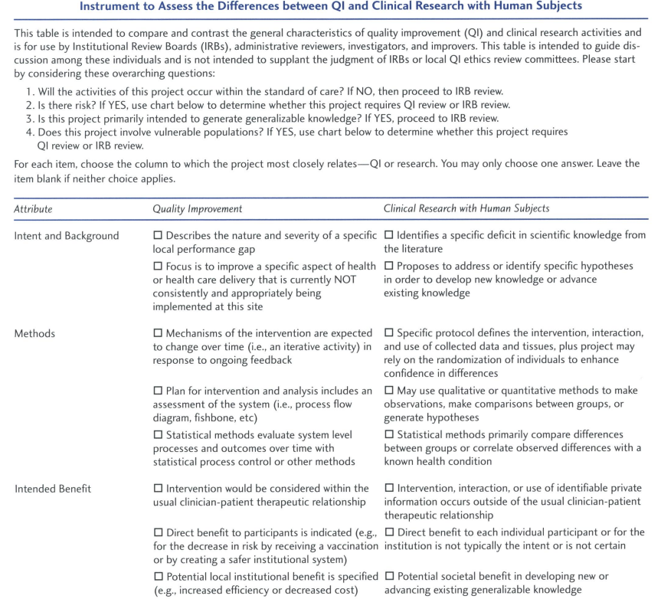

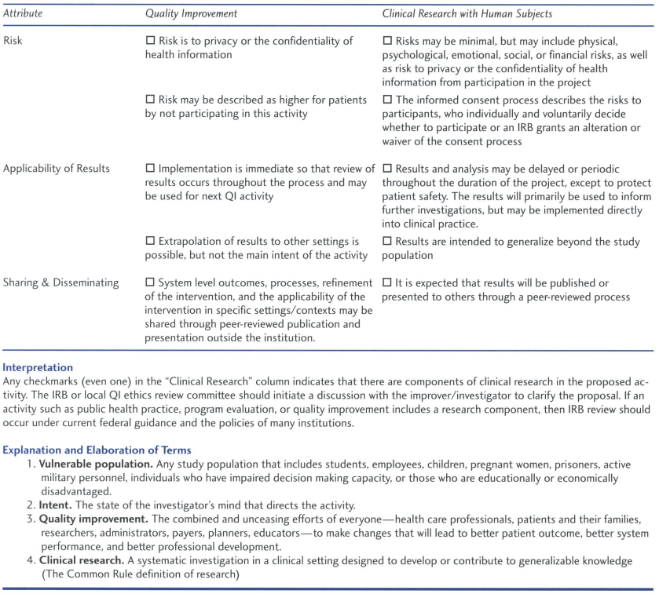

Appendix 2: Research Data Request Workflows

Neither RIDGe nor DUA required (Data not disclosed outside DH)

Only DUA Required (Data disclosed outside DH)

Only RIDGe Required (Data not disclosed outside DH. Approval needed for special data or apps)

Both RIDGe and DUA required – less common (Data disclosed outside DH. Approval needed for special data or apps)

Manual Chart Review with Analytics Institute assistance – RIDGe review required

Manual Chart Review without Analytics Institute assistance – RIDGe review required

See next pages for Workflow diagrams

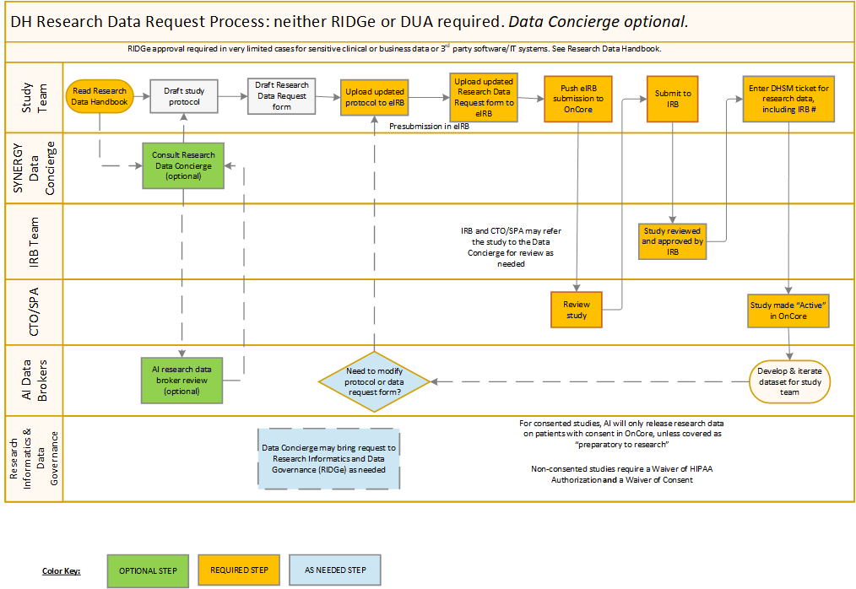
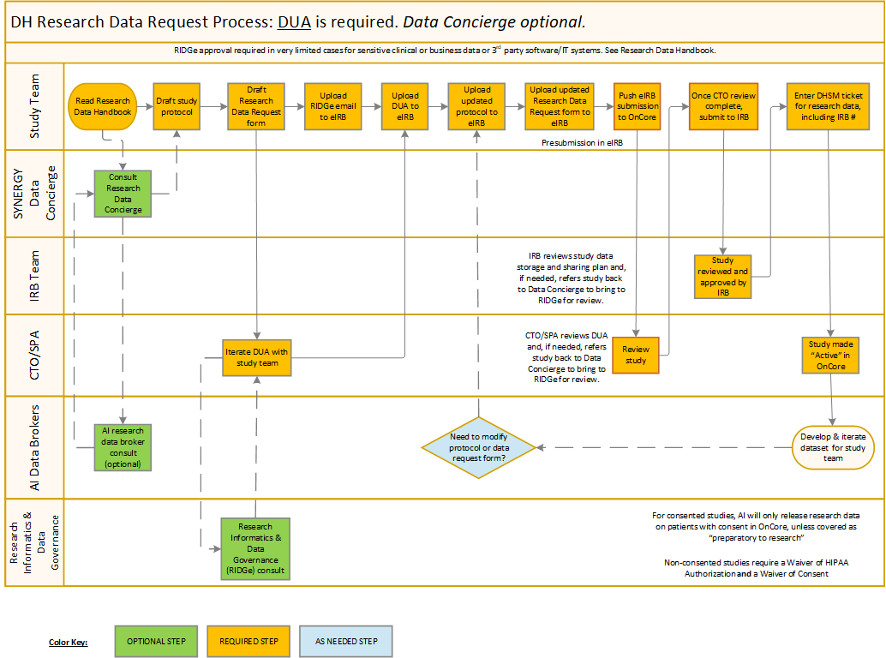
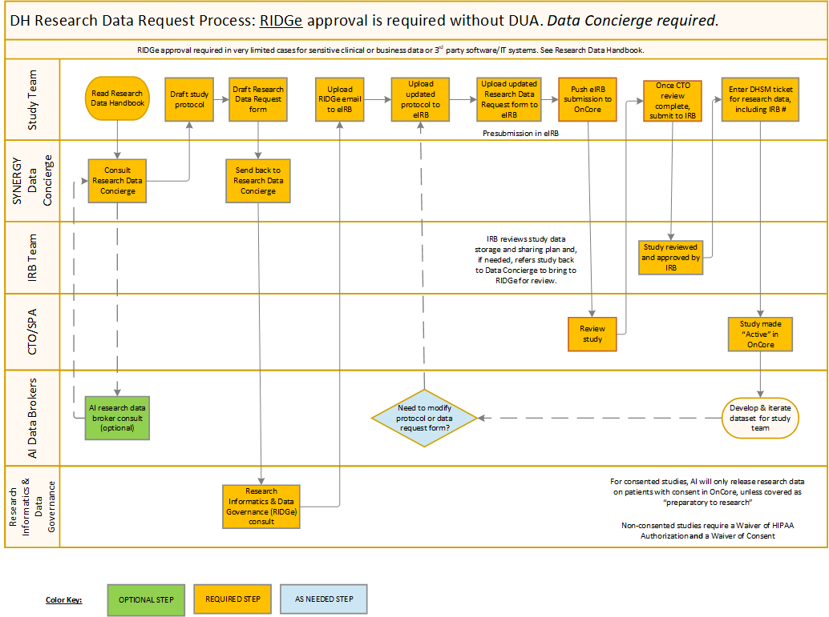
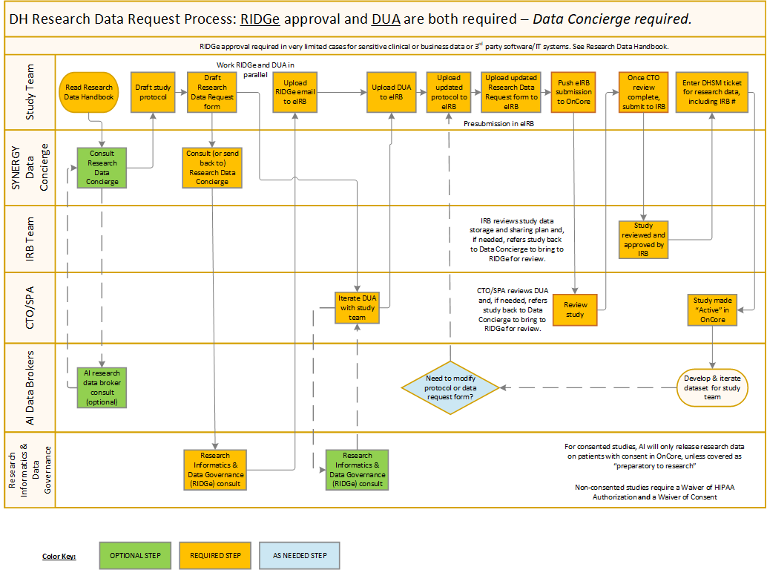
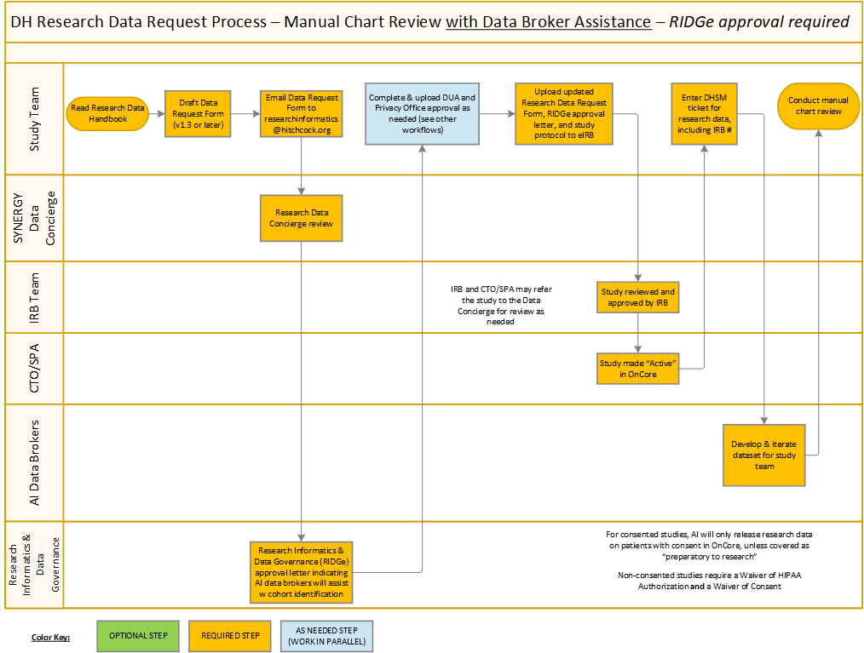
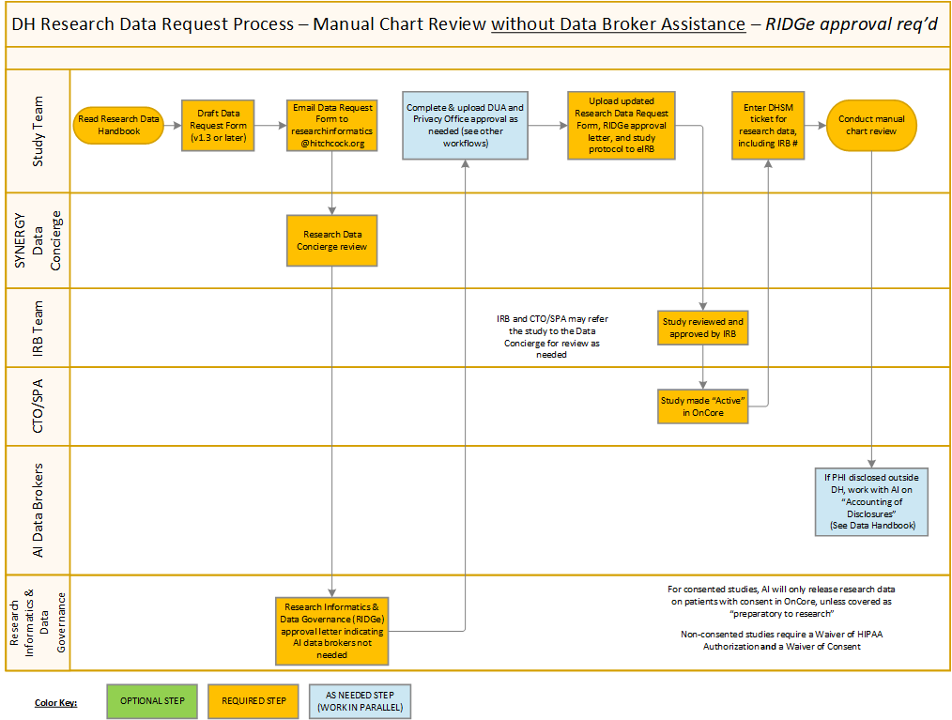

See “Use of Clinically Sensitive or Business Confidential Data” in this handbook regarding data from substance use treatment encounters.
See “Use of Clinically Sensitive or Business Confidential Data” in this handbook regarding use of HIV and genetics testing

